|  |
| --- |
| Digital Analyst Team |
| Cookie User Manual |
| Manual Ver 1.0 |

|  |
| --- |
| Varghees S  11/22/2016 |



# Document Control

**Revision history**

| Version | Issue date | Author/editor | Description/Summary of changes |
| --- | --- | --- | --- |
| 1.0 | 11/22/2016 | Varghees S | First Draft |
|  |  |  |  |

**Reviewed by**

| Version | Issue date | Name | Position | Reviewdate |
| --- | --- | --- | --- | --- |
| 1.0 |  |  |  |  |
|  |  |  |  |  |
|  |  |  |  |  |

**Approvals**

| Version | Issue date | Name | Position | Approval date |
| --- | --- | --- | --- | --- |
|  |  |  |  |  |
|  |  |  |  |  |

# Table of Contents

Cookie 4

Login To Cookie 4

Main Menus 5

Dashboard 6

Dashboard – Summary 7

Dashboard - Media 8

Dashboard - URL 9

Dealer 10

Start Tracking Dealer’s Website 11

View Dealer’s Profile 12

Reports 13

Generate Report 14

Conversions 15

Logout 16

**Cookie**

The Cookie is a powerful web application with a point-and-click dashboard tool that helps view the visitors’ conversion statistics.

**Login To Cookie**

* Click the link*:*[*http://ec2-35-160-235-13.us-west-2.compute.amazonaws.com:8080/webanalytics/*](http://ec2-35-160-235-13.us-west-2.compute.amazonaws.com:8080/webanalytics/)
* Or Copy and paste the link in the browser

The Login page is shown.

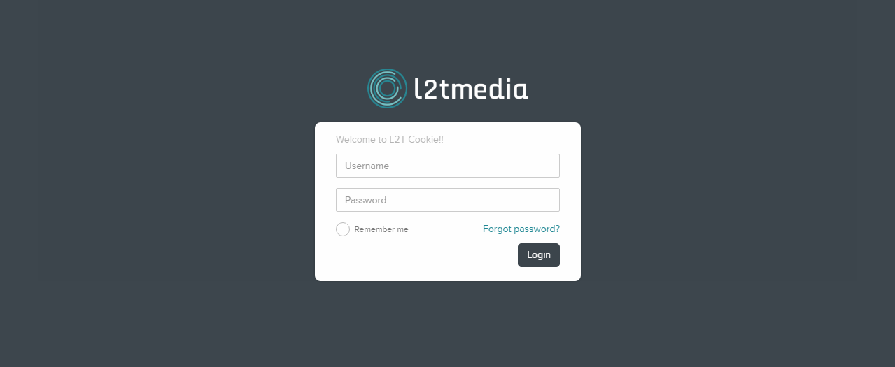

* Enter the Username and Password.
* Click Login.
  + *Select the Remember Me option to store the username and password before clicking Login.*

Successful login will take you to the below page

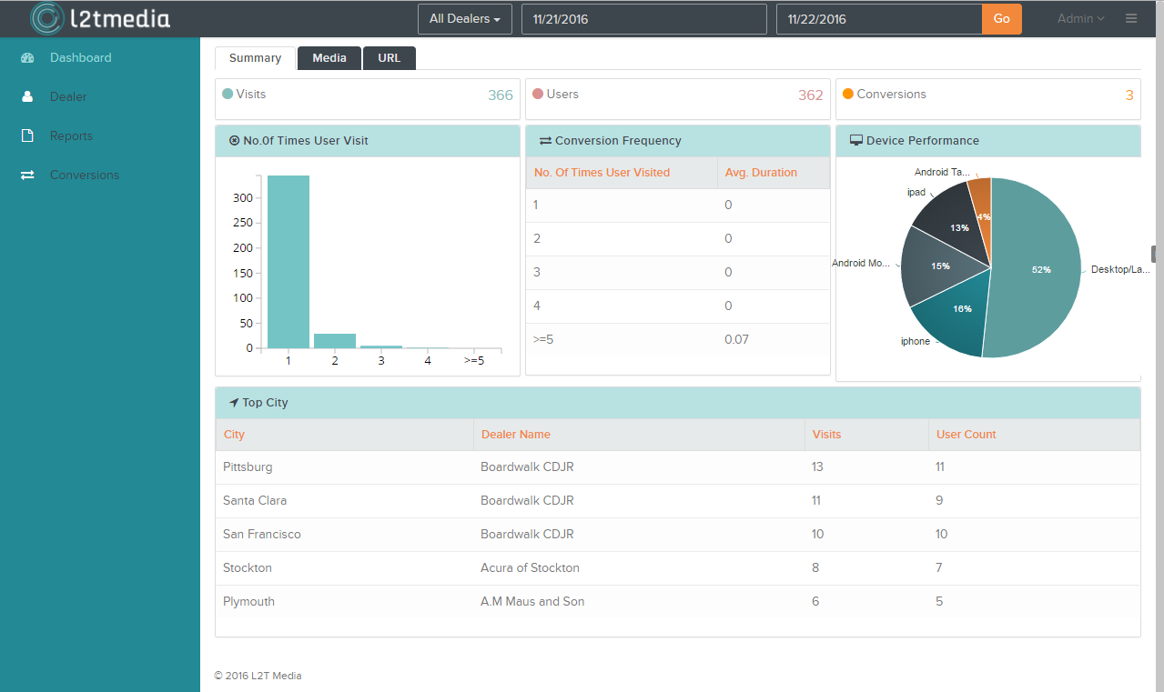

**Main Menus**

The four main menus are

1. Dashboard
2. Dealer
3. Reports
4. Conversions

**Dashboard**

The Dashboard helps you get info on

* Visitor counts,
* Conversion frequency,
* Device performance,
* Geo location of the visitor,
* Referral media and
* ReferralDomains.

You can get dashboard information for a specific dealer or all dealers within a specified date range.

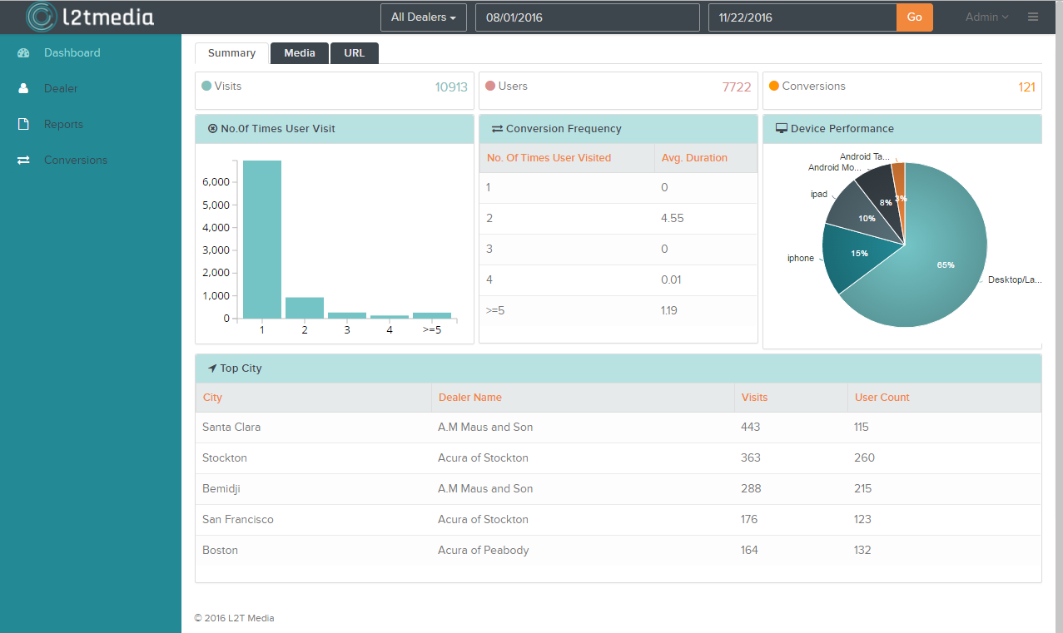

The three tabs on the Dashboard menu are

1. Summary
2. Media &
3. URL

**Dashboard – Summary**

The Summary tab shows the conversion summary.

* First, select a specific dealer or All Dealers from the drop down menu seen at the top of the screen.
* Then specify the date range [from and to date] for which you want to view the information.
* Click Go.

The Dashboard -Summary page is shown.



You can view

* Total Visits,
* Total Users and
* Total Conversions for the specified period.

The Bar chart shows the number of visitors who visited once, twice, thrice, four times, and 5 times or more.

The Conversion Frequency shows the average duration taken by the visitor to become a customer.

The Pie Chart, Device Performance, shows the device used by the visitors.

The Top City lists the

* City
* Dealer name
* Number of visits and
* User count from that particular city for the dealer.

**Dashboard - Media**

The Media tab provides referrer info through which the visitor visited the dealers’ website during his first, consecutive and last visits.

* Click on the **Media** tab

The Dashboard-Mediapageisshown.

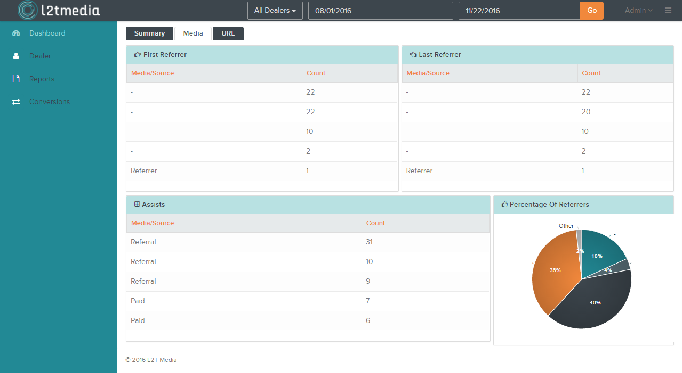

The First Referrer shows the source media from which the users visited our dealers’ website during their first visit.

*The First Referrer may be paid search, organic search or social media.*

The Last Referrers shows the source media from which the users visited during the conversion visit.

The Assists show the source media from which the users visited the dealer’s website during each visit.

The Pie chart, Percentage of Referrers, shows the proportion of media/source from which we get our visitors.

**Dashboard - URL**

The URL tab shows the referrer domain source from where the visitor’s first, last and intermediate visits originated.

* : Click on the **URL** tab

The Dashboard-URLpageisshown.

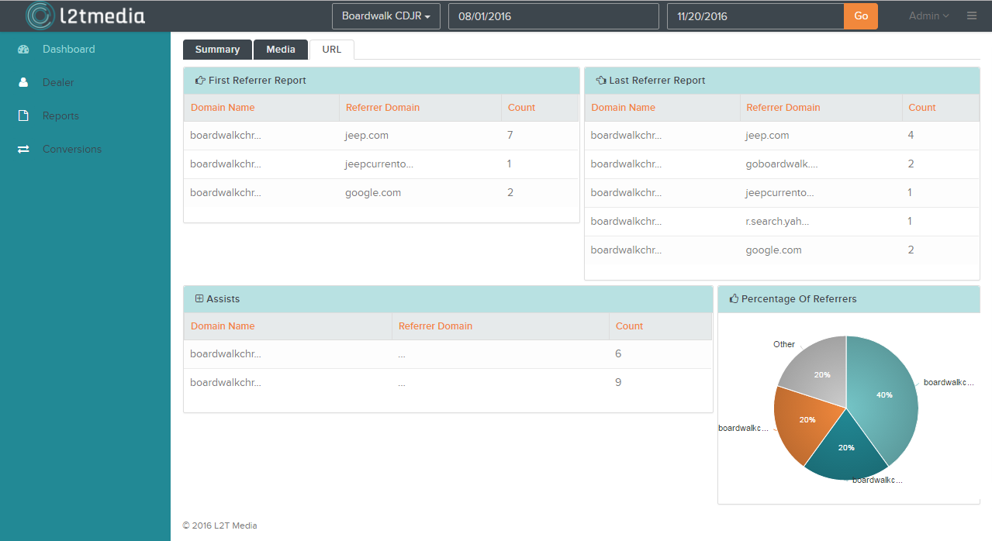

The First Referrer Report shows the

* Domain Name of the dealer,
* Referrer Domain from which the first visit is made and
* The visitor count from that referrer domain.

The Last Referrer Report shows the

* Domain Name of the dealer,
* Referrer Domain from which the last (or conversion) visit is made and
* The visitor count from that referrer domain.

The Assists shows the

* Domain Name of the dealer,
* Referrer Domain from which every visit is made and
* The total visitor from that referrer domain.

The Pie chart, Percentage of Referrers, shows the proportion of visitors from every Referrer Domain.

**Dealer**

The Dealer Menu shows All dealers count, Active dealers count and Inactive dealers count.

By default, the list of all available dealers is shown along with their

* Website URL,
* Email Address,
* Last report generated date & time and
* Active status.
  + Green tick mark indicates the dealer is active and a red cross indicates the dealer is inactive.

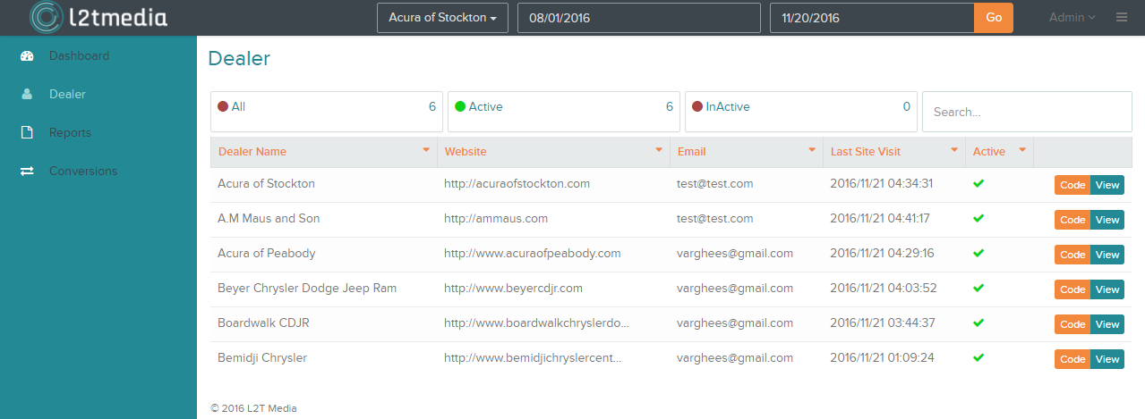

* Type the dealer name in the Search field to find a specific dealer.

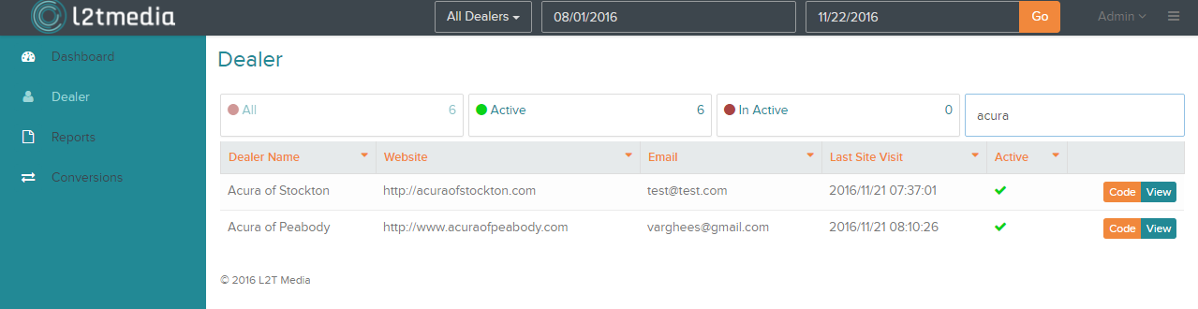

* Click the small arrow on the column headers to sort the list.

**Start Tracking Dealer’s Website**

* Click the Code.

A code snippet is displayed in a popup window.

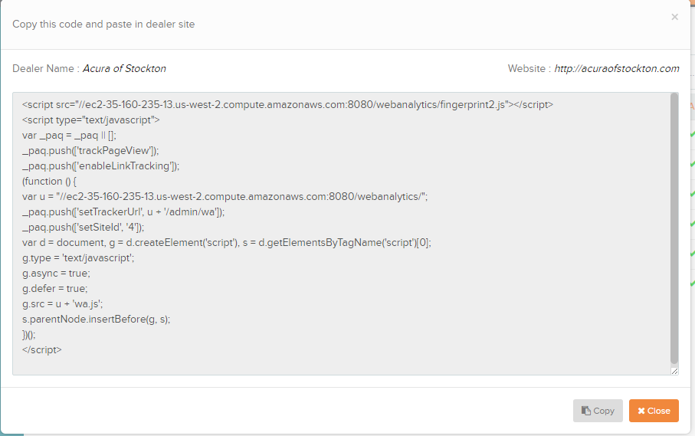

* Click Copy in the popup window to copy the code and paste it in the dealers’ website.

*This code enables to track the conversion statistics of the website*

* Click Close to close the popup window.

**View Dealer’s Profile**

* Click View to view the profile of the dealer in a separate popup window.

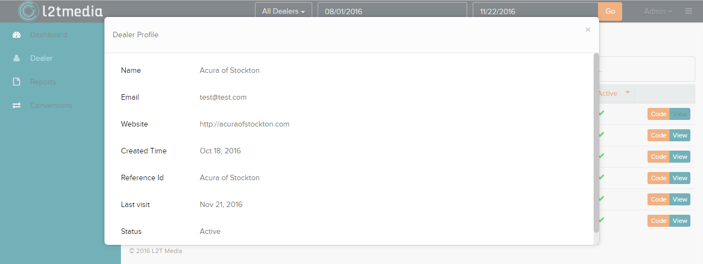

* Close the popup window to exit.

**Reports**

The Report enables you to get complete information about

* Visitors’ geo,
* Device type,
* Referrer media
* Referrer URL,
* Total visits and
* Unique visits.
* Click Reports menu on the left to generate a comprehensive report on All Dealers or a specific dealer.
* Select a specific dealer or All Dealers from the drop down menu placed in the top of the screen.
* Then specify the date range [from and to date] for which you want to generate the report.
* Click Go.

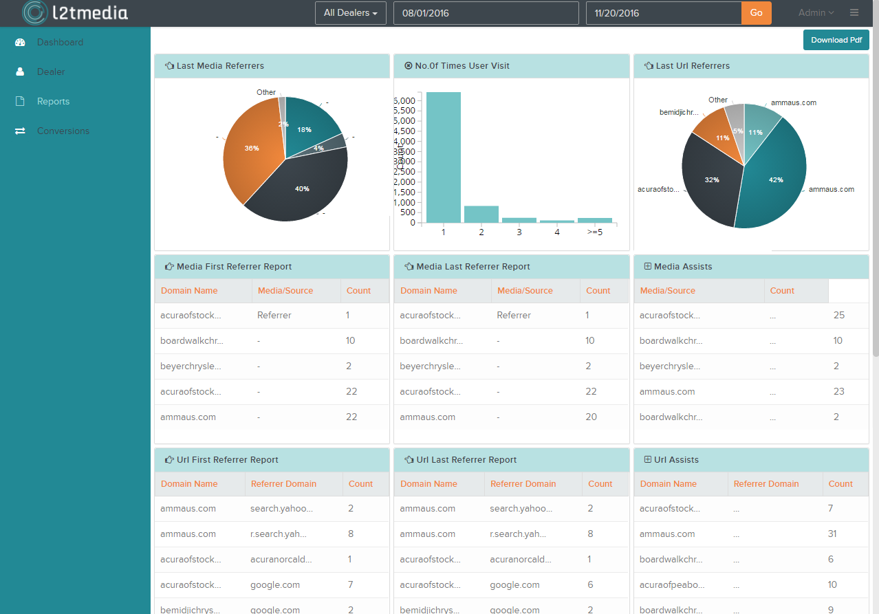

**Generate Report**

* Click Download PDF to download the generated report in the PDF format.

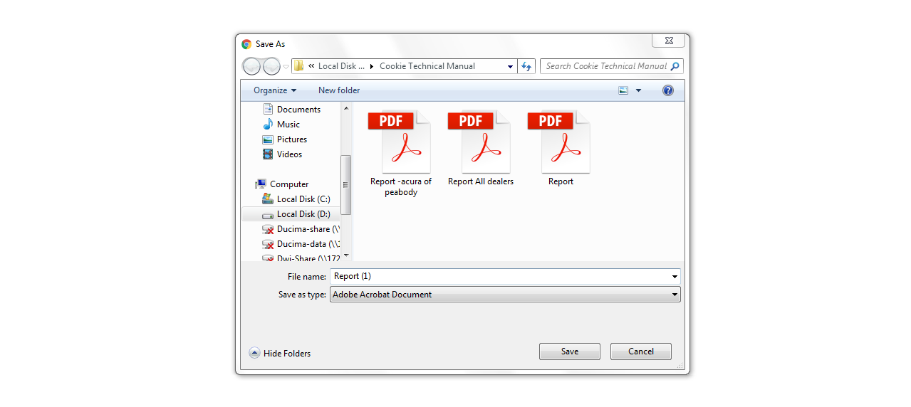

* Choose the preferred location and directory.
* Enter the preferred File name.
* Click Save to save the report.

**Conversions**

The Conversions menu enables you to get detailed information about the visiting pattern of the customers.

* Click Conversions menu on the left to get conversion details of All Dealers or a specific dealer.
* Select a specific dealer or All Dealers from the drop down menu placed in the top of the screen.
* Then specify the date range [from and to date] for which you want to view the conversion detail.
* Click Go.

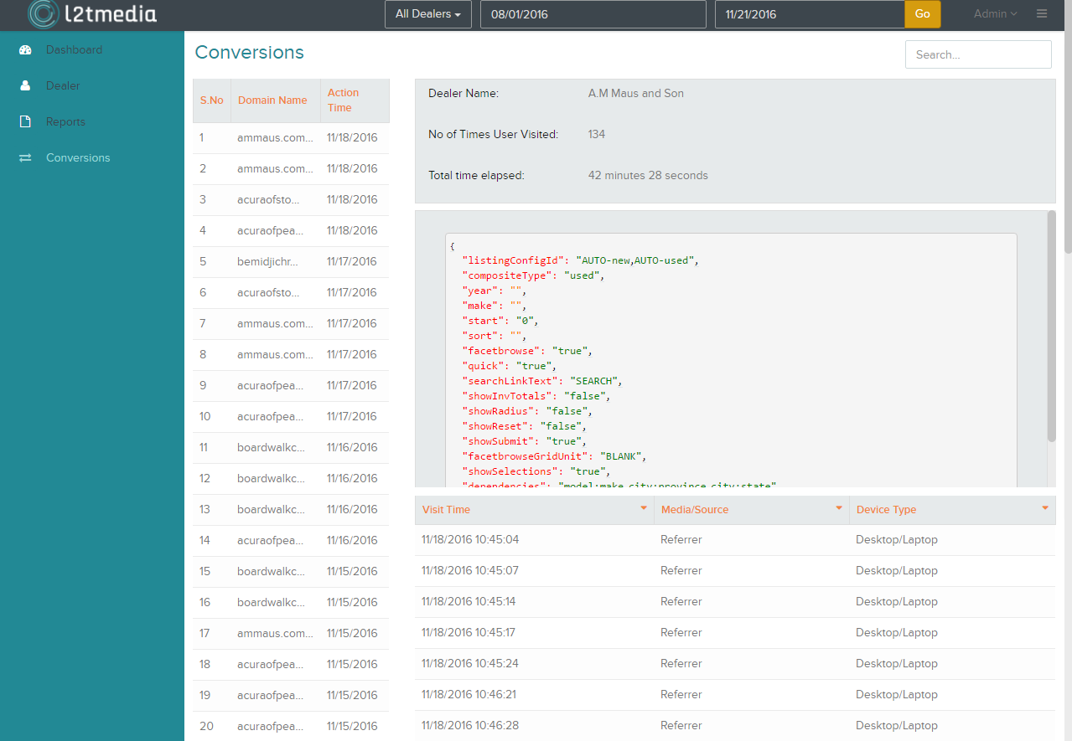

The Conversions, lists all the conversions happened in the specified time period.

* Click a particular conversion.

You can view the

* Dealer name
* The number of times the user visited the dealer’s website and
* The time elapsed between the first visit and the conversion visit.

The Code snippet shows the action code triggered by the user during conversion.

The list below the code snippet showsthe information on every visit namely

* The time visited,
* Referrer media/source and
* Device type used by the visitor
* Click the small arrow on the column headers to sort the list.

**Logout**

To Logout of the application

* Click the Admin on the top right.

Logout appears as a pull down menu.



* Click Logout.

The application is closed and Login screen is shown.